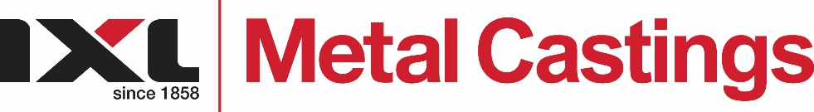 | IXL Metal Castings  1-15 Wood Street  South Geelong, 3220  Tel: (03) 5225 2222  Fax: (03) 5229 5062  Email: foundry@ixl.com.au
Reliability Fitter/Maintenance Supervisor
The IXL Group is committed to our businesses and our people for over 165 years. We invest in our people and seek to build organisational excellence and capacity through these people. Our organisation seeks individuals that are aligned to the values of Safety, Honesty, Integrity, Respect, Teamwork, Innovation and Excellence.
If you are a talented person looking for a role with meaning in a committed team environment, due to a growing business, IXL Group is offering an opportunity to be part of our Metal Castings team.
The Reliability Fitter/Maintenance Supervisor is responsible to ensure the preventative and fault-finding maintenance is carried out in a safe and effective manner, having consideration for production activities and schedules. The role is a permanent 9-day fortnight day shift position and will require supervision and leadership of a team with a strong focus on the development of apprentices.

The Role
- Ensure Preventative maintenance mindset and servicing of all production equipment and foundry facilities is carried out in safe and timely manner
- Responsible for fault finding and breakdown analysis
- Responsible for all foundry tools and ensures no tools are left in production areas
- In consultation with Production staff, identifies equipment and areas requiring attention
- Ensures, continual review of production line equipment to ensure optimal effectiveness is carried out
- Co-ordinates with sub-contractors for maintenance tasks

Experience and Skill
- Successfully completed an apprenticeship in metal trades
- 5+ years maintenance experience preferably in manufacturing industry
- Effective communication, both written and verbal
- Effective time management
- Experience in. but not limited to, installation, operation, service, fault finding, repair and maintenance of plant equipment such as chain belt and roller conveyor transport systems, saws, compressors, shot blast units, vacuum systems and pumps
- Experience with compliance and quality systems (ISO 9001:2015)
- Strong interpersonal, business processes and achieving outcomes skills
- Understanding of OHS requirements highly desirable
- Experience in welding (MIG and/or ARC) highly desirable
- Forklift License (desirable)
- Understanding of Microsoft Suite is desirable

The individual
- Enthusiastic and willing to learn new ways of doing business
- A “can do” attitude with an enthusiastic approach to the challenges at hand
- Comfortable working in an environment of change
- Ability to listen and explain in simple easy to understand terms
- Supervisory experience particularly with guiding apprentices

If you are interested in the role and believe you have the skills and experience to make a major contribution, please click on the “apply” button and provide your CV and cover letter.

If you are interested in the role and believe you have the skills and experience to make a major contribution, please provide your CV and Cover Letter to recruitment@ixl.com.au

