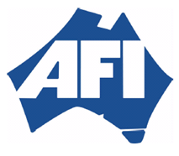  AUSTRALIAN FOUNDRY INSTITUTE  (WESTERN AUSTRALIA DIVISION INC.) |  | 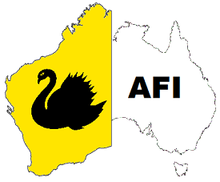

2021 Technical Program:

Date | Topic | Speaker
Closed | Current and Future Foundry Consumable Technology Trends | Ryan Webber
Closed | Making Heads and Tails of Safety Culture. | Dr Tristan Casey
Closed | Good Steel Making | Jim West
29/09/21 | Thermal Analysis of Iron & Steel with Regards to Casting Quality & Preparation Free Sampling. | Charles Hurst
11/10/21 | Joint AFIWA and WA Materials Australia Technical Evening | Eddy Derwort
28 - 30th  October 2021 – Postponed to May 2022. | AFI National Conference - Rydges Hotel Southbank, Brisbane, Queensland.  “Don’t Stop Thinking About Tomorrow” | Various
24/11/21 | AFIWA AGM + Technical presentation (Foundry 4.0) | Stuart Ward

If you are interested in attending any of the above presentations, either in person or by video, please contact the Secretary – secretaryafiwa@gmail.com

