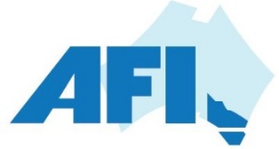 Australian Foundry Institute (Vic Branch) 2022 Program v8
Month | Date | Location | Topic | Presenter | AFI / ADCA Contact
Feb | Wed 16th | Village Green | Robotic Fettling of Castings - presentation | Fred Kolak | Graham W
Mar | Wed 16th | Geelong | Newcomb HS and GMC Presentation / Bill Pratt 100th Celebration |  | Sean B
Apr |  |  | No activity scheduled for April
May | Thur 12th – Sat 14th | Brisbane | National Conference |  | AFI(Qld)
June | Wed 22nd | Hawthorn | Industry 4.0 Swinburne Tech – site visit |  | Alan C
Jul | Wed 20th | Dandenong | Arrow Bronze - site visit |  | Matthew P
Aug | Wed 17th | Village Green | Quicksand presentation | Adam Hassell | Alan C
Sep | Fri 2nd | Sovereign Hill, Ballarat | Annual Technologists Picnic - presentation |  | Gary Bunn - MA
Sep | Wed 14th | Carrum Downs | Australian Brass Forgings – site visit | Gary Thompson | Graham W
Oct | Wed 16th – 20th | Busan, Sth Korea | WFO Congress
Oct | Wed 19th | Village Green | Legends Night and AGM |  | Amber M
Nov | Wed 16th | Village Green | Energy Action presentation | Raechel Kent | Wolfgang M
Dec | Wed 8th | Errols, Nth Melb | Planning meeting

